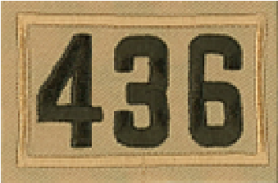

CLASS-B UNIFORM ORDER SHEET

Troop 436 Scouts must wear the traditional Class-A uniform for all Scoutmaster Conferences, Board of Review Meetings, Courts of Honor, Dinners at Boy Scout Camp, and whenever representing BSA in public.

For all other Troop meetings and events the scouts should wear a CLASS-B uniform T-Shirt or sweatshirt. The shirts have a Troop 436 emblem embroidered on the left chest area. Parents/Leaders may also order items for themselves to wear for scout activities.

Please complete the form below and return via email to Kieran Rafter: kmrafter@gmail.com.

MAKE CHECKS PAYABLE TO: BSA Troop 436 OR VENMO: @Kevin-OShea-81526

Scout / Parent Name _______________________ Phone Number ___________________

Email Address_________________________________

All Items Navy Blue & Adult Sizes | Small | Med | LG | XL | 2XL | 3XL | Price | Total  Price
Dry-fit Short Sleeve Shirt |  |  |  |  |  |  | $24.00  ($26 for 2X & 3X)
Dry-fit Long Sleeve Shirt |  |  |  |  |  |  | $26.00  ($32 for 2X & 3X)
Dry-fit Hoodie Pullover |  |  |  |  |  |  | $38.00  ($45 for 2X & 3X)
Cotton Hooded Sweatshirt |  |  |  |  |  |  | $35.00  ($41 for 2X & 3X)
Winter Beanie with 436 Embroidery |  |  |  |  |  |  | $19.00  (One Size)
Baseball Hat with 436 Embroidery – Stretch Fit |  |  |  |  |  |  | $25.00  (One Size)
Cinch Sack (Screen-Printed) |  |  |  |  |  |  | $11.00  (One Size)
TOTAL QUANTITY |  |  |  |  |  |  | TOTAL COST

